Bring Your Own Device (BYOD)
Bring your own device is an optional program where parents and carers can provide personal digital devices for use at school. The specifications required for bring your own device:

Wireless connectivity: 5GHz
- Operating system:
- Microsoft Windows 10 or later
- Current Apple macOS
- Current Apple iOS
- Chrome OS

- Software and apps:
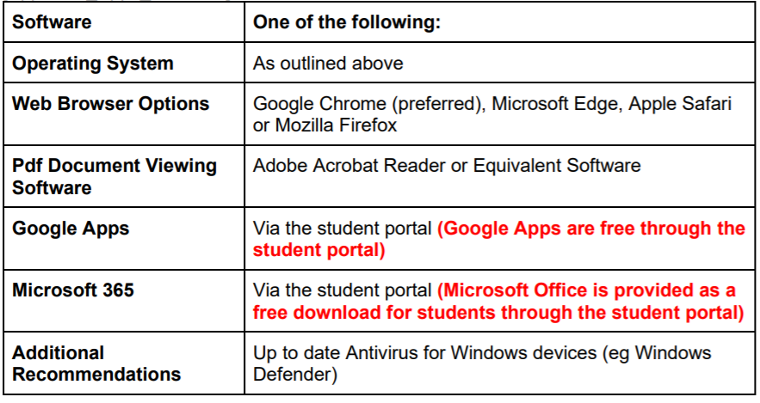
- Battery life
  - Advertised battery life of 6 hours or more.

- Storage and RAM
  - Minimum 64GB storage on Windows device.
  - A SSD (solid state disk) is recommended.
  - Minimum Ram: Laptops 4GB / Tablets 1GB

- Hardware features
  - Laptop, tablet device or convertible device.
  - A tablet device must have a physical keyboard attachment with separate keys for A – Z and 0 – 9 and which physically move when depressed.
  - Minimum Screen Size: 9.7”.
  - Maximum Screen Size: 13.3”
  - The department’s Wi-Fi network installed in high schools operates on the 802.11a/n 5Ghz standard. Devices must be able to connect to the 802.11a/b/g/n 5Ghz wireless network. Look for 802.11AC as this is the latest standard and will definitely work.
  - Dual core processor or better. Minimum processor speed 1.5GHz – A quad core device is recommended.
  - A SIM and ability to connect to a phone network is NOT required and discouraged as all internet connection at school MUST be through the school's provided network connections.
  - Students are required to store their device in a suitable protective case when not in use.
  - A scratch/impact/liquid-splash resistant case is recommended. A screen protector may also be advisable for touch screen devices

- Accessories and other considerations:
  - Maximum weight: 2kg, USB 2.0 or USB 3.0 port
  - Accidental loss and breakage Insurance
  - Up to date Antivirus for Windows devices (eg Windows Defender)

